Homework # A : NYPL New Catalog Final Report

Ruchi Panwar(rpanwar@kent.edu)

Software Testing

Fall 2015

Professor: Dr. Gregory S DeLozier

Nov 6, 2015

**Introduction**

Being the fourth largest public library in the world and second in the United States, the New York Public Library contains nearly 53 million items to display to the public. In order to incorporate newer features into the original catalog, NYPL has introduced a newer version of the website that is expected to be more interactive and easier to use.

Original Catalog: <http://catalog.nypl.org>

New Catalog: <http://browse.nypl.org>

**Purpose**

This Test Report provides a summary of the results of tests performed to determine whether the new catalog of NYPL satisfies acceptance criteria .

**Testing Limitations**

All test performed are limited to non-members.

**Test Plan**

|  |  |  |  |  |  |
| --- | --- | --- | --- | --- | --- |
| **NEW YORK PUBLIC LIBRARY - TEST RESULTS** | | | | | |
| **Sl No** | **Process ID** | **Test Description** | **Tested By** | **Status** | **Comments** |
| 1 | UI testing |  |  |  |  |
| 1.1 |  | Option to refine the book search by availability. | Ruchi Panwar | Completed | Works fine for new catalog. |
| 1.2 |  | Option to refine the book search by format. | Ruchi Panwar | Completed | Works fine for new catalog. |
| 1.3 |  | Option to refine search results by language. | Ruchi Panwar | Completed | Works fine for new catalog. |
| 1.4 |  | Option to sort the books by date. | Ruchi Panwar | Completed | Works fine for both the catalogs. |
| 1.5 |  | Option to sort the books by title. | Ruchi Panwar | Completed | Works fine for both the catalogs. |
| 2 | Database Test |  |  |  |  |
|  |  |  |  |  |  |
| 2.1 |  | Search a book by a keyword and check the result count. | Ruchi Panwar | Completed | Works fine for both the catalogs. |
| 2.2 |  | Option to search a book by ISBN number and verify the result. | Ruchi Panwar | Completed | Works fine for both the catalogs. |
| 2.3 |  | Verify whether SQL Injections are allowed. | Ruchi Panwar | Completed | Works fine for both the catalogs. |
| 3 | Advanced Features |  |  |  |  |
| 3.1 |  | Verify whether user can save the record. | Ruchi Panwar | Completed | Works fine for new catalog. |
| 3.2 |  | Verify whether user can forward the record via email option. | Ruchi Panwar | Completed | Works fine for new catalog. |
|  |  |  |  |  |  |
|  |  |  |  |  |  |
|  |  |  |  |  |  |

**Test Results**

Please find the below screen shot with the test results, obtained from automated selenium web-driver program. Each test case has been discussed in details in the next section - Test Report.

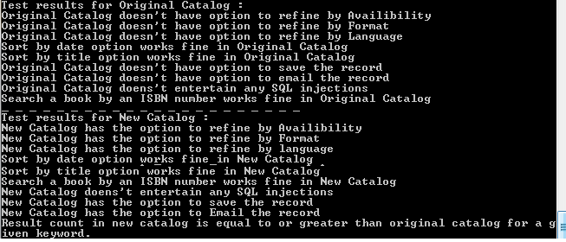

**Test Report**

**Case 1: Option to refine the book search by availability.**

This is the advanced feature offered in the new catalog to refine the book search by availability such as, how many books are available at the library and how many are available online. You can choose the books as per your convenience.

This option is not available in the original catalog.

**Case 2: Option to refine the book search by format.**

This is the advanced feature offered in the new catalog to refine the book search by format such as, how many books are available in the form of text, e-book, web resource etc. You can choose the books as per your need.

This option is not available in the original catalog.

**Case 3: Option to refine search results by language.**

This is the advanced feature offered in new catalog to refine the book search by language such as how many books in which language.

This option is not available in the original catalog.

**Case 4: Option to sort the books by date.**

This feature is fine (same as original catalog) in the new catalog.

**Case 5: Option to sort the books by title.**

This feature is fine (same as original catalog) in the new catalog.

**Case 6: Search a book by a keyword and check the result count.**

The result count for a given keyword in the new catalog is most of the time greater than and equal to the older catalog count. In some cases, the count is less and it seems that the new catalog has taken off the records that were not relevant.

**Case 7: Option to search a book by ISBN number and verify the result.**

Though, new catalog doesn't have specific option to search the book "By ISBN" like the original catalog, but if we enter the ISBN number directly in the search box , the results are as accurate as the original one.

**Case 8: Verify whether SQL Injections are allowed.**

New Catalog doesn't entertain any SQL injections and it's as secure as the original one.

**Case 9: Verify whether user can save the record.**

This is an advanced feature, very user friendly. It provides an option to save the record for each result. Users need not go to the specific book/result to save it unlike the original catalog. The options is available right there.

**Case 10: Verify whether user can forward the record via email option.**

This is the best feature available in the newer catalog to send the record via email.

This option is not available in the original catalog.

**Conclusion**

The new catalog of NYPL seems to be a good deal, as it's very user friendly and interactive. It provides loads of advanced features such as, refine the search result by availability, format, language, publish date etc. It also has the option to save the records as well as email the records. All the advanced options available in the new catalog are easy to use and navigate.

The search results of the new catalog, seem to be very reliable and accurate. It tries to minimize the count of non-relevant records, and hence sometimes the count of the new catalog search results is less than the original one.

Though the performance is little low compared to original catalog, but it not bothersome. The new catalog is a pretty good option, it's reliable in terms of accuracy of results and at the same time very trendy.

**References**

*https://* *www.google.com/\**

*https://en.wikipedia.org/wiki/\**

*http://catalog.nypl.org*

*http://browse.nypl.org*